Purposes:

1. Establishing a new benchmark in large-sample hydrological modeling using the VIC model.
2. Evaluating calibration performance using additional observational resources for streamflow prediction and facilitating knowledge transfer from gauged to ungauged basins.

Scenario 1 : calibration based on streamflow show the performance of other hydrologic variables (SM, water storage, evapotranspiration, or etc) and then calibration based other hydrologic variables in ungauged basins and evaluate streamflow , transfer knowledge of routing parameters through Regionalization

Scenario 2: Scenario 2, transfer routing parameters through Random forest

Scenario 3: Transfer all the parameters to the ungauged basins through ML models and physical and geographical features

1. Assimilating USGS streamflow observations into the VIC model across 517 basins to generate an hourly hydrological dataset encompassing all key hydrological variables.

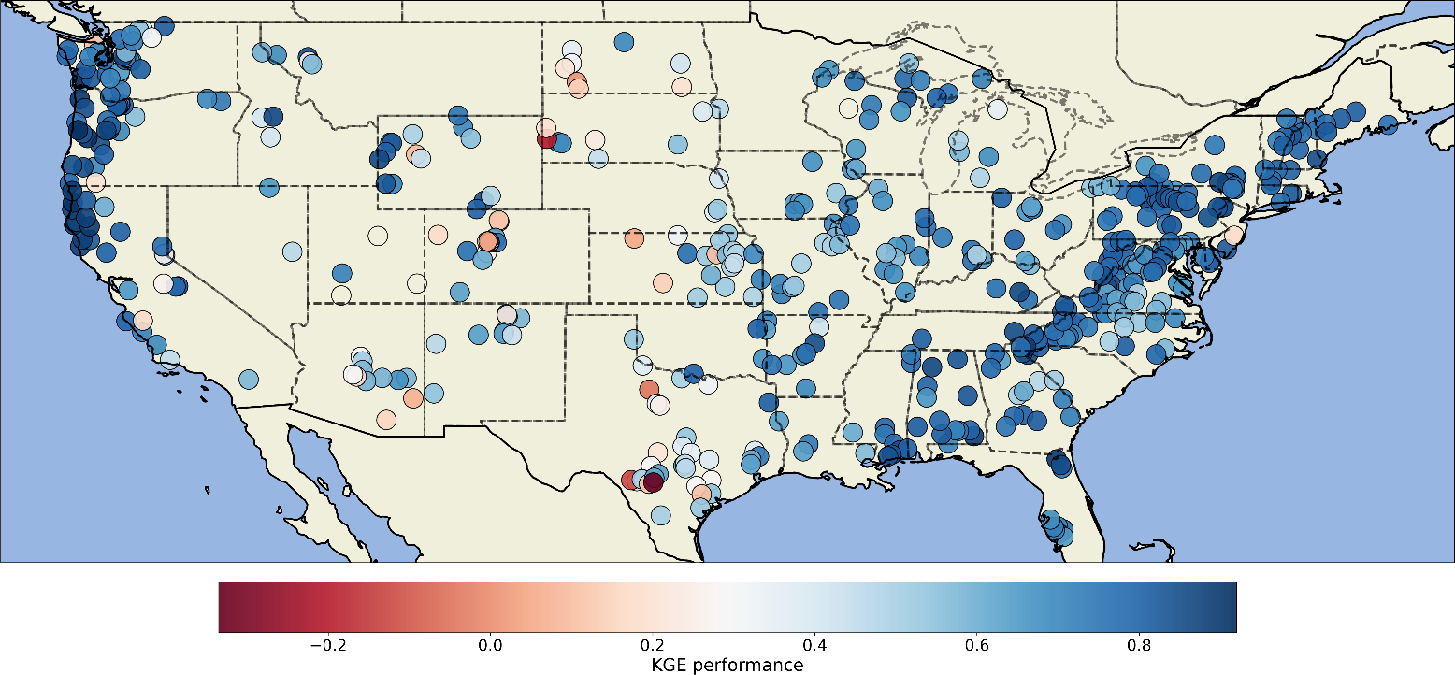

KGE median : 0.7232821620032044

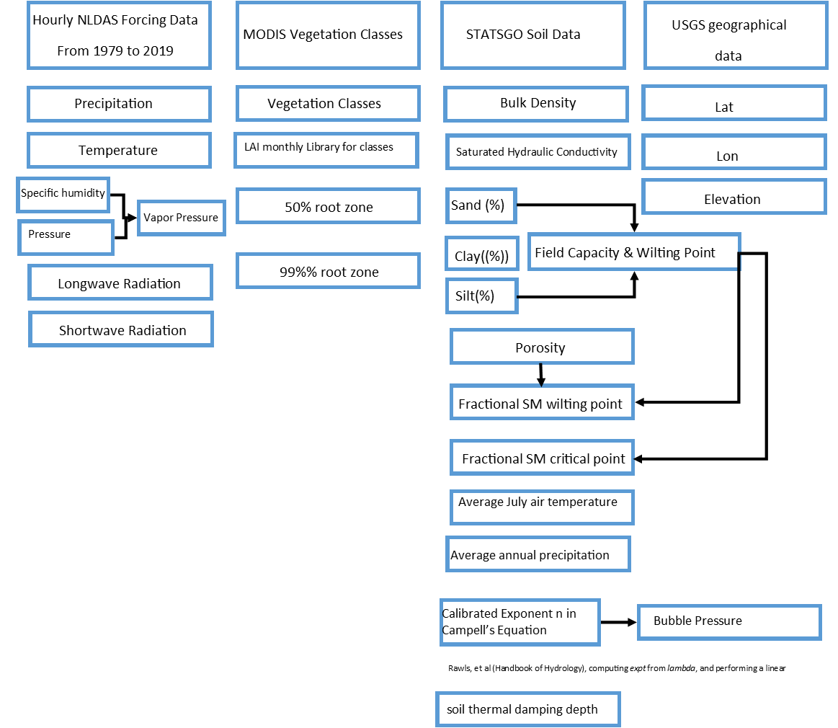

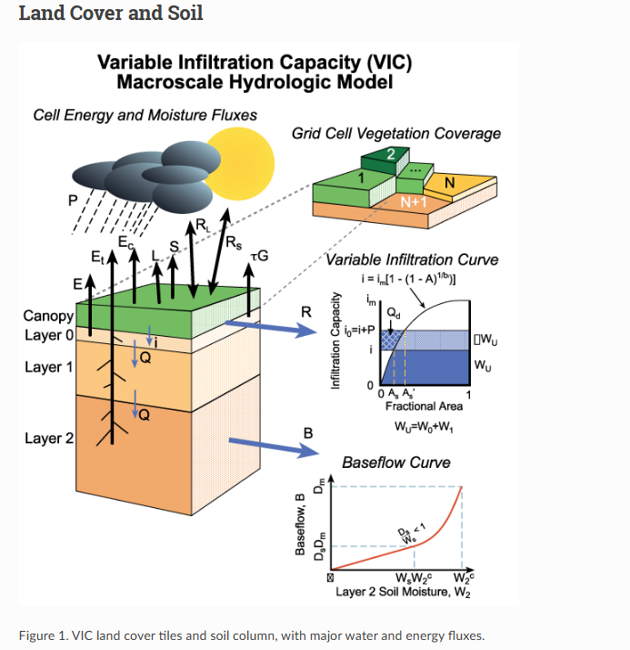

* Greater value of binf yields lower infiltration and more runoff (Qd)
* Amount of infiltration capacity relative to the saturated gridcell area

Baseflow

* Linear at low soil moisture content

– Reduces responsiveness of baseflow during dry conditions

* Non-linear at high soil moisture content

– Rapid baseflow response during wet conditions

Linear base flow

Ds - [>0 to 1] This is the fraction of Dsmax where non-linear (rapidly increasing) baseflow begins. With a higher value of Ds, the baseflow will be higher at lower water content in lowest soil layer.

Dsmax - [>0 to ~30, depends on hydraulic conductivity] This is the maximum baseflow that can occur from the lowest soil layer (in mm/day).

Ws - [>0 to 1] This is the fraction of the maximum soil moisture (of the lowest soil layer) where non-linear baseflow occurs. This is analogous to Ds. A higher value of Ws will raise the water content required for rapidly increasing, non-linear baseflow, which will tend to delay runoff peaks.

binf - [>0 to ~0.4] This parameter defines the shape of the Variable Infiltration Capacity curve. It describes the amount of available infiltration capacity as a function of relative saturated gridcell area. A higher value of binf gives lower infiltration and yields higher surface runoff.

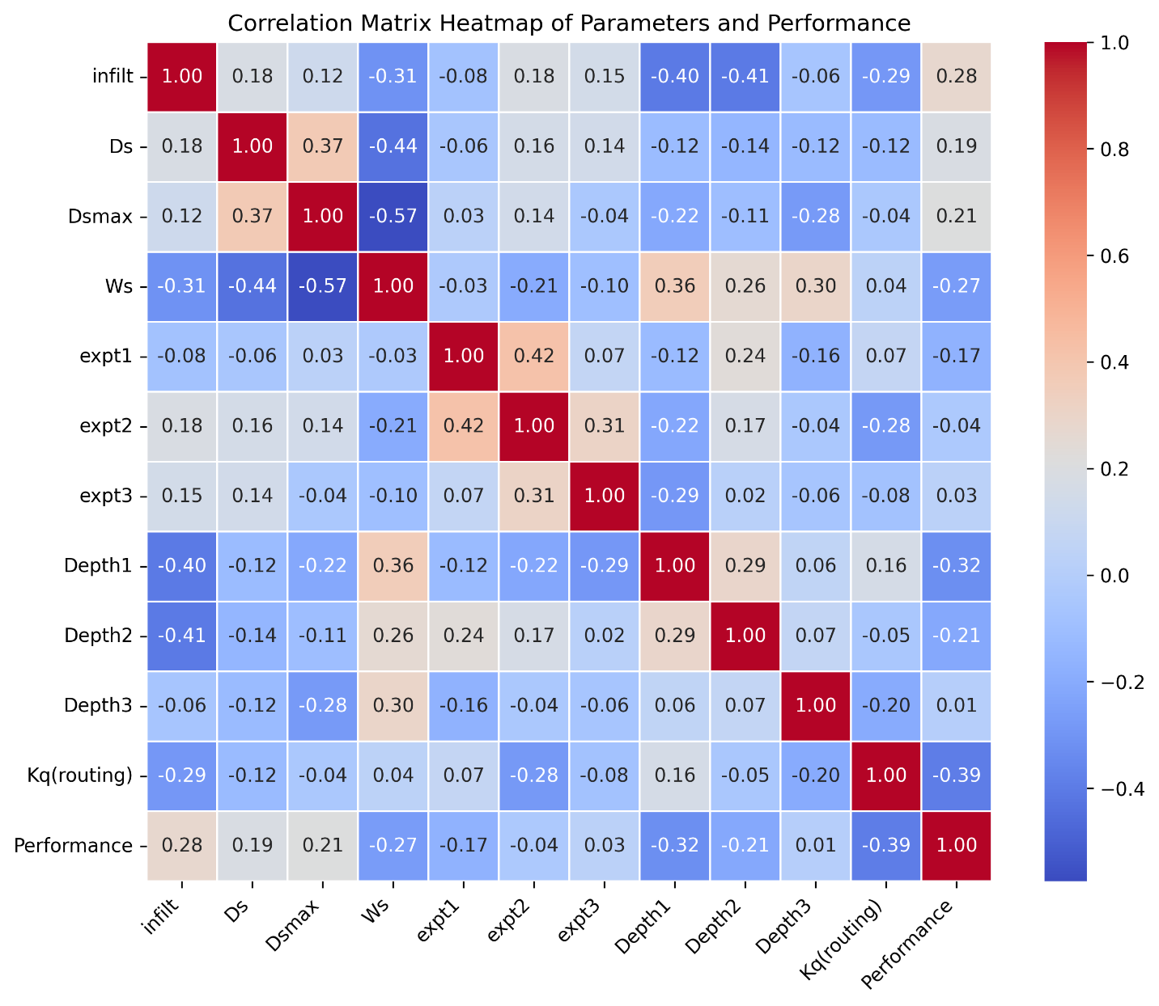

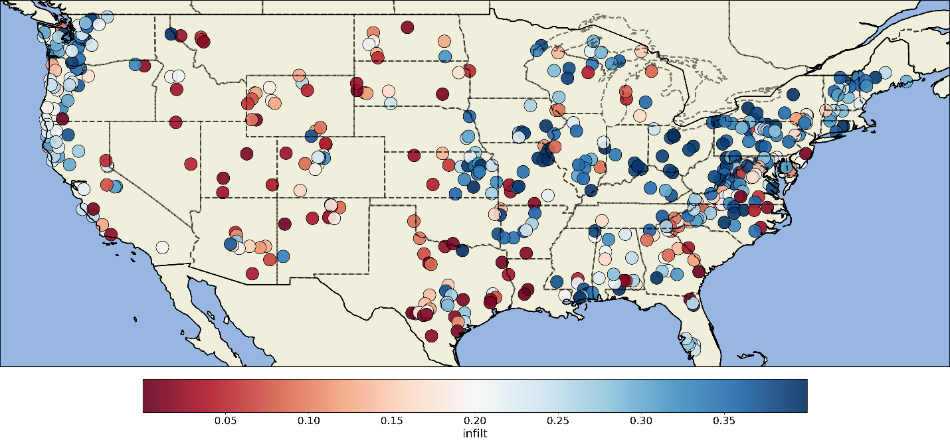

Variable infiltration curve parameter (binfilt)

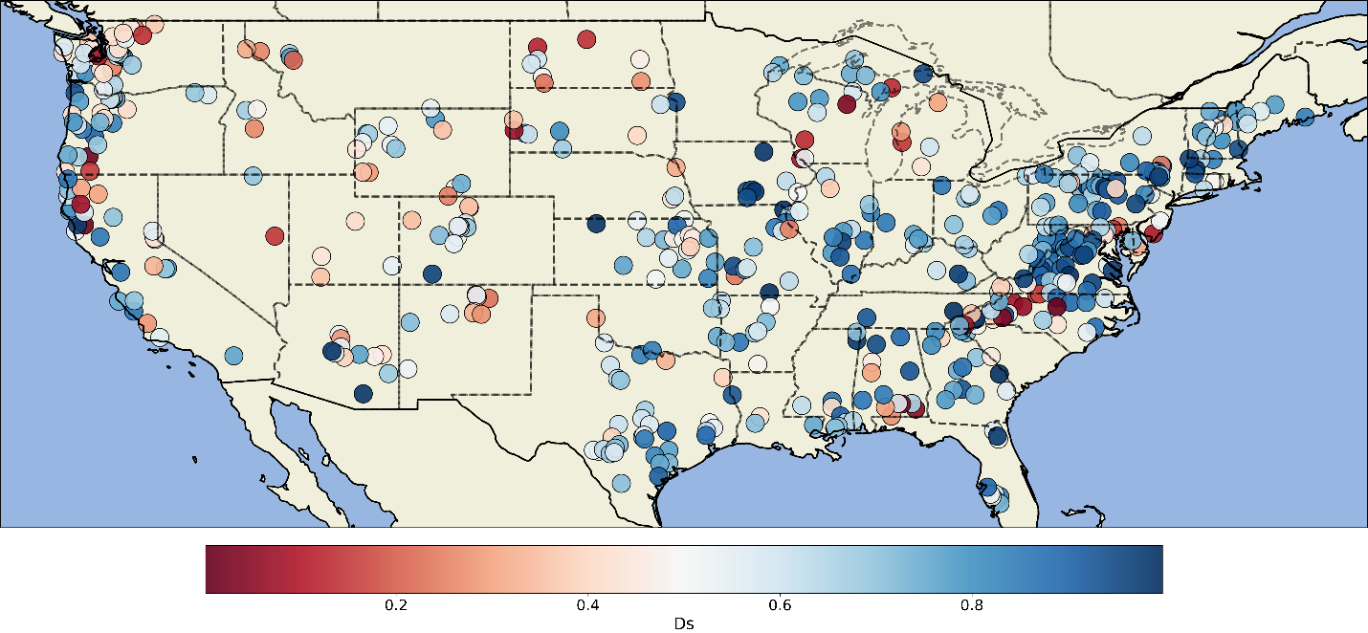

Fraction of Dsmax where non-linear baseflow begins

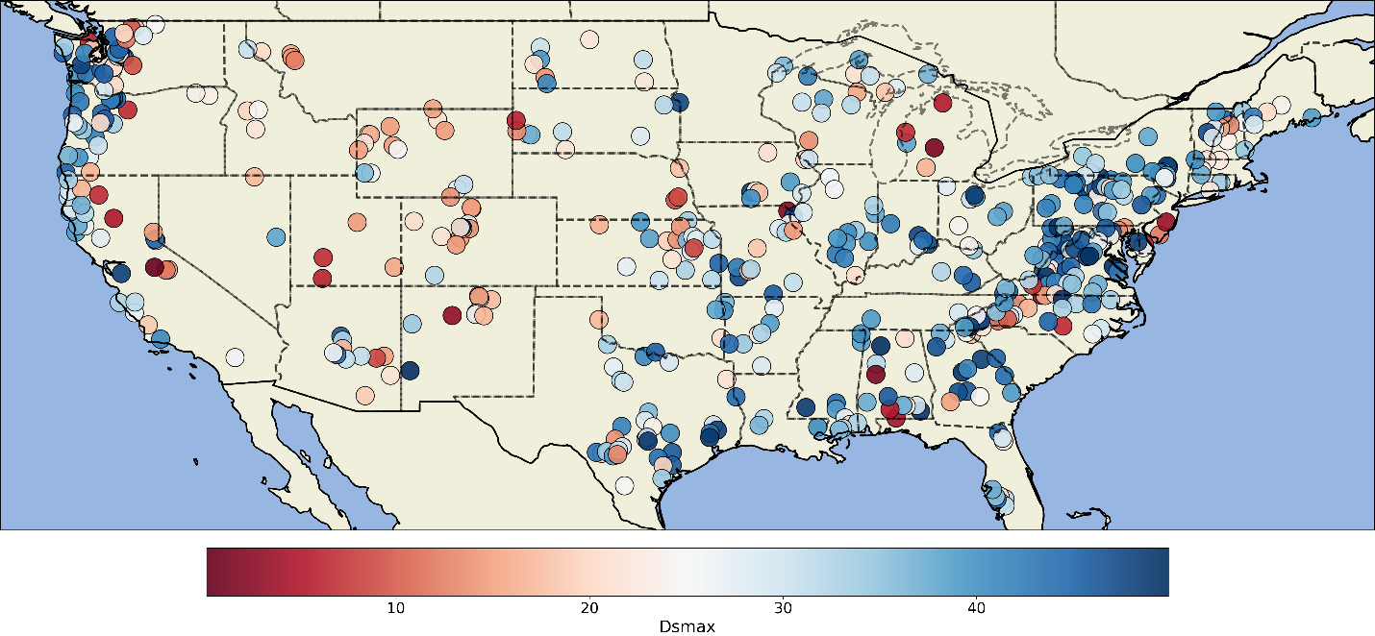

Maximum velocity of baseflow (maximum baseflow)

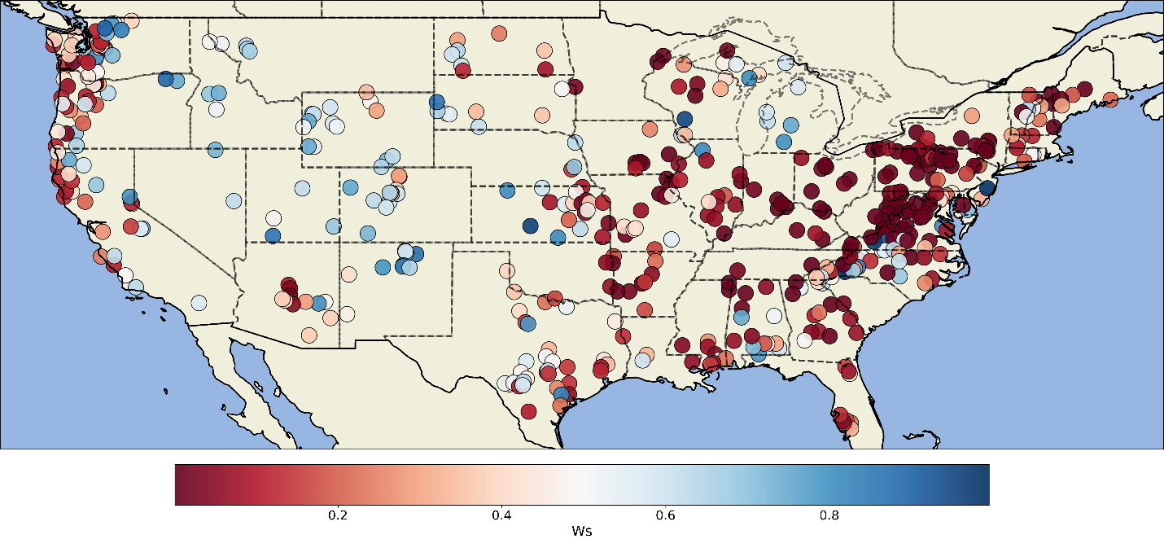

Fraction of maximum soil moisture where non-linear baseflow occurs

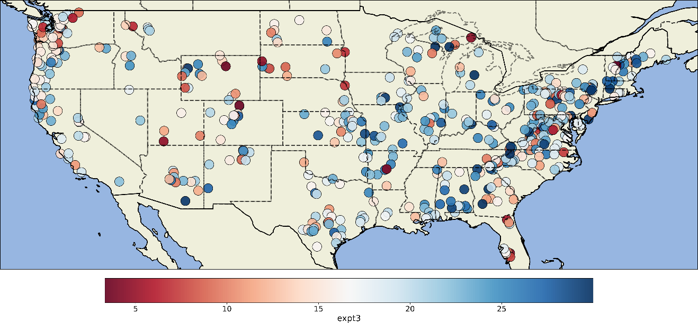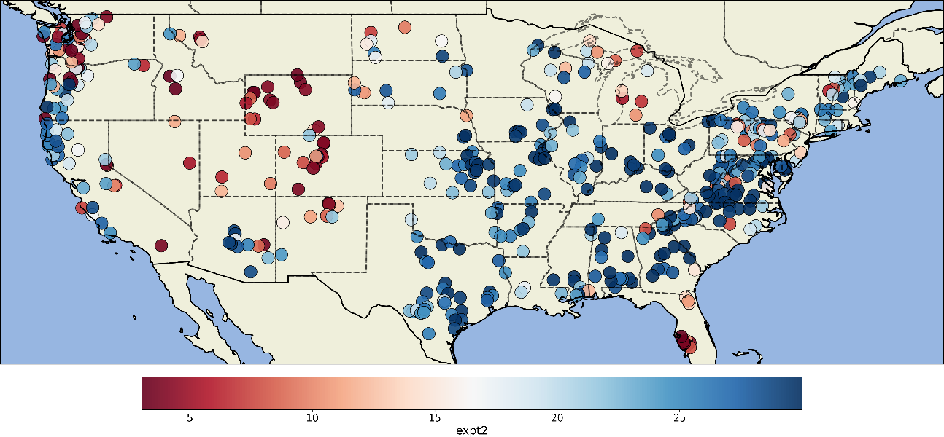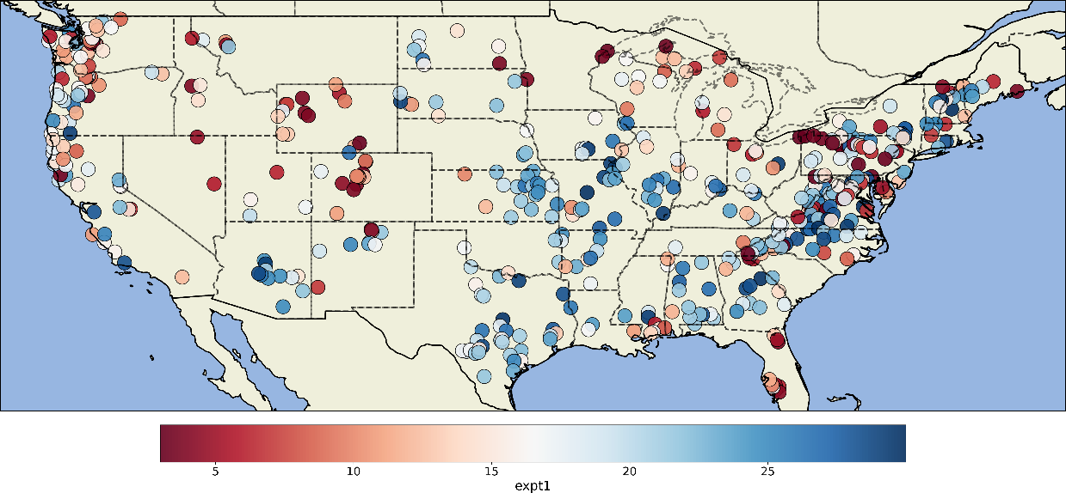

Exponent n in Campbell's eqn for hydraulic conductivity

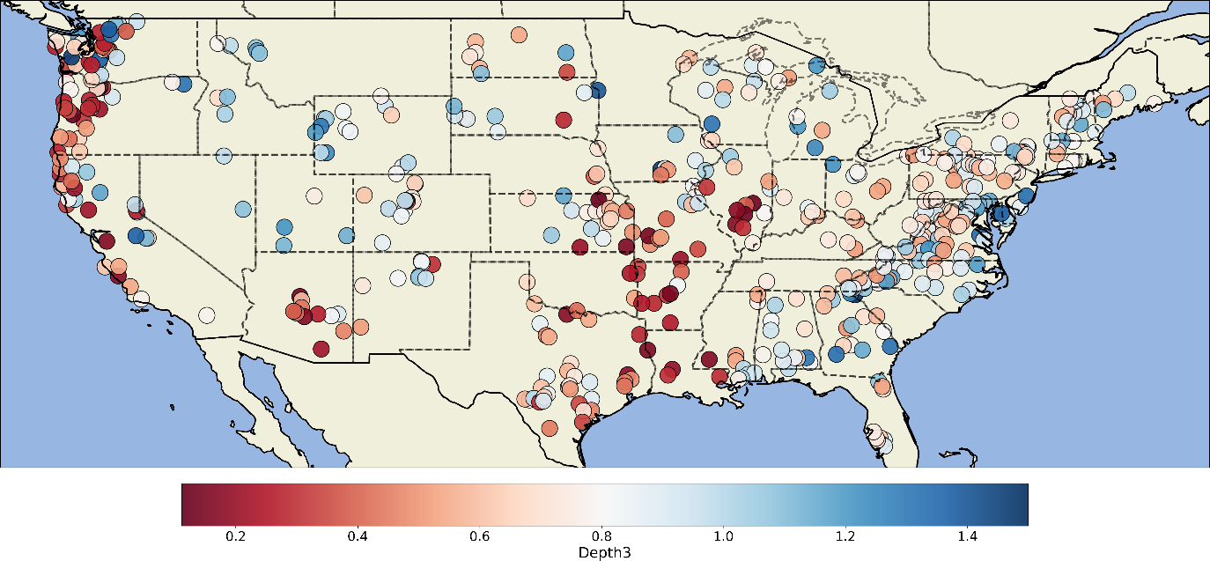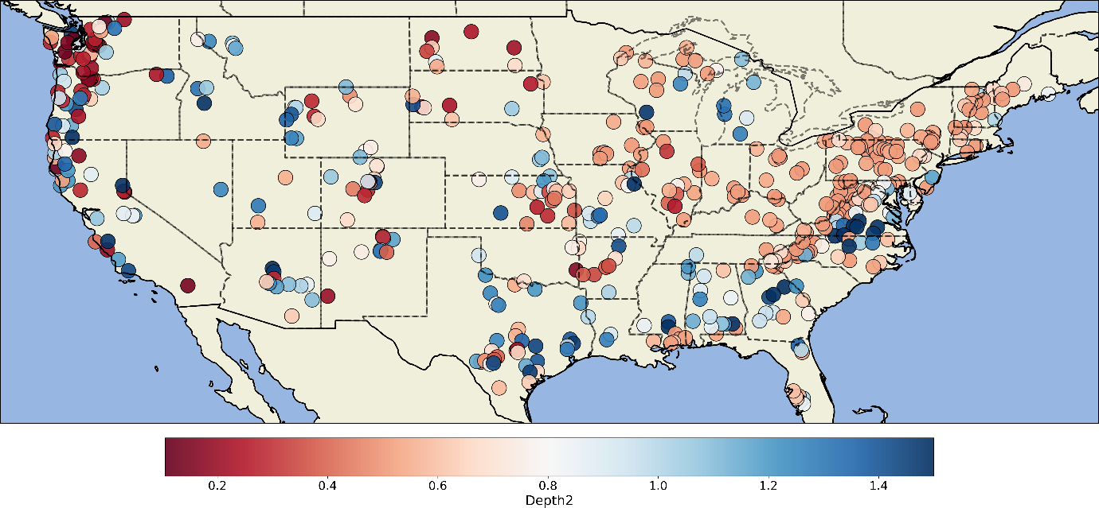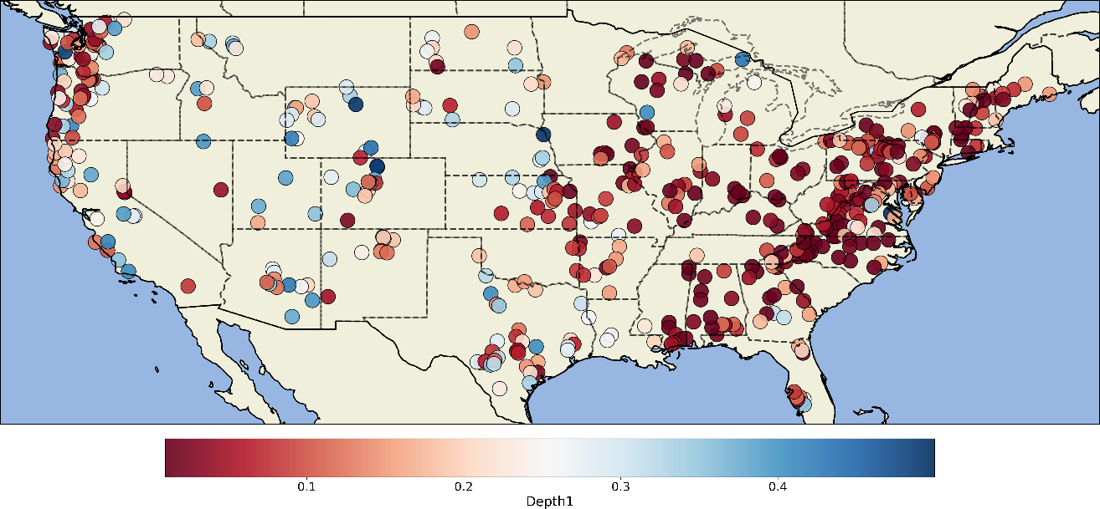

Soil Depth